
Proverbs 16:3 & Romans 10:9
RED LION YOUTH FOOTBALL
Age 8-9 Division 2026 – Teams should arrive 1 hour prior to their game for practice
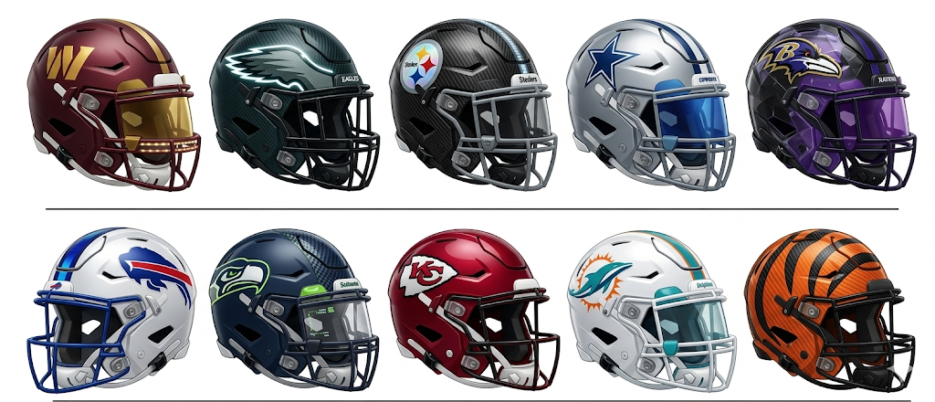
Everyone must play at least 50% of the Game * THINK POSITIVE BE POSITIVE
Date Time Home Team Away Team Field
Week 1 - * ARRIVE 1 hour prior to your game for practice * THINK POSITIVE BE POSITIVE !
- Sun 3/29/2026 2:15 pm Steelers vs. Eagles #1 - Stadium
- Sun 3/29/2026 2:15 pm Seahawks vs. Bills #2 – Stadium
- Sun 3/29/2026 2:15 pm Cowboys vs. Bengals #3 – Turf
- Sun 3/29/2026 2:15 pm Ravens vs. Chiefs #5- Turf
- Sun 3/29/2026 2:15 pm Commanders vs. Dolphins #7- Grass

4/5/26 WE are off on Easter Sunday * Happy Easter and Resurrection DAY!
We wish you and your families a very Happy Easter and a meaningful Resurrection Day. We look forward to seeing everyone back and energized next week!


Proverbs 16:3 & Romans 10:9
RED LION YOUTH FOOTBALL
Age 8-9 Division 2026 – Teams should arrive 1 hour prior to their game for practice
Everyone must play at least 50% of the Game * THINK POSITIVE BE POSITIVE
Week 2 * ARRIVE 1 hour prior to your game for practice * THINK POSITIVE BE POSITIVE !
- Sun 4/12/2026 2:15 pm Steelers vs. Commanders #1 - Stadium
- Sun 4/12/2026 2:15 pm Eagles vs. Seahawks #2 – Stadium
- Sun 4/12/2026 2:15 pm Dolphins vs. Cowboys #3 – Turf
- Sun 4/12/2026 2:15 pm Bengals vs. Ravens #5- Turf
- Sun 4/12/2026 2:15 pm Bills vs. Chiefs #7- Grass

Week 3 * ARRIVE 1 hour prior to your game for practice * THINK POSITIVE BE POSITIVE !
- Sun 4/19/2026 2:15 pm Ravens vs. Dolphins #1 - Stadium
- Sun 4/19/2026 2:15 pm Steelers vs. Cowboys #2 – Stadium
- Sun 4/19/2026 2:15 pm Eagles vs. Commanders #3 – Turf
- Sun 4/19/2026 2:15 pm Seahawks vs. Chiefs #5- Turf
- Sun 4/19/2026 2:15 pm Bills vs. Bengals #6- Grass

Proverbs 16:3 & Romans 10:9
RED LION YOUTH FOOTBALL
Age 8-9 Division 2026 – Teams should arrive 1 hour prior to their game for practice
Everyone must play at least 50% of the Game * THINK POSITIVE BE POSITIVE
Date Time Home Team Away Team Field
Week 4 * ARRIVE 1 hour prior to your game for practice * THINK POSITIVE BE POSITIVE !
- Sun 4/26/2026 2:15 pm Dolphins vs. Bills #1 - Stadium
- Sun 4/26/2026 2:15 pm Bengals vs. Seahawks #2 – Stadium
- Sun 4/26/2026 2:15 pm Cowboys vs. Commanders #3 – Turf
- Sun 4/26/2026 2:15 pm Eagles vs. Chiefs #5- Turf
- Sun 4/26/2026 2:15 pm Steelers vs. Ravens #6- Grass

Week 5 * ARRIVE 1 hour prior to your game for practice * THINK POSITIVE BE POSITIVE!
- Sun 5/3/2026 2:15 pm Commanders vs. Ravens #1 - Stadium
- Sun 5/3/2026 2:15 pm Chiefs vs. Bengals #2 – Stadium
- Sun 5/3/2026 2:15 pm Seahawks vs. Dolphins #3 – Turf
- Sun 5/3/2026 2:15 pm Bills vs. Steelers #5- Turf
- Sun 5/3/2026 2:15 pm Cowboys vs. Eagles #6- Grass


*WE ARE OFF ON 5/10/26 HAPPY MOTHER’S DAY!
We want to take this opportunity to wish all of our mothers and grandmothers a very Happy Mother’s Day! We hope you have a wonderful day of celebration and relaxation with your families!

Proverbs 16:3 & Romans 10:9
RED LION YOUTH FOOTBALL
Age 8-9 Division 2026 – Teams should arrive 1 hour prior to their game for practice
Everyone must play at least 50% of the Game * THINK POSITIVE BE POSITIVE

Week 6 * ARRIVE 1 hour prior to your game for practice * THINK POSITIVE BE POSITIVE!

- Sun 5/17/2026 2:15 pm Cowboys vs. Ravens #1 - Stadium
- Sun 5/17/2026 2:15 pm Dolphins vs. Chiefs #2 – Stadium
- Sun 5/17/2026 2:15 pm Eagles vs. Bengals #3 – Turf
- Sun 5/17/2026 2:15 pm Commanders vs. Bills #5- Turf
- Sun 5/17/2026 2:15 pm Seahawks vs. Steelers #6- Grass

* WE ARE OFF ON 5/24/26 – HAPPY MEMORIAL DAY WEEKEND. THANK YOU TO ALL WHO SERVED, and THANK YOU TO ALL OF THOSE WHO GAVE THE ULTIMATE PRICE FOR OUR FREEDOM!


PLAYOFFS BEGIN NEXT WEEK!

Proverbs 16:3 & Romans 10:9
RED LION YOUTH FOOTBALL
Age 8-9 Division – Teams should arrive 1 hour prior to their game for practice
Date Time Home Team Away Team Field
Week 7 * Round 1 of the Playoffs
Everyone must play at least 50% of the Game * THINK POSITIVE BE POSITIVE

- Sun 5/31/2026 2:15 pm Seed 1 vs. Seed 4 #1 – Stadium
(Winner of Game 31 advances to the Super Bowl on 6/8)
(Non-Winning Team will play Non-Winning team of Game 32 in the D1 Championship on 6/8)

- Sun 5/31/2026 2:15 pm Seed 2 vs. Seed 3 #2 – Stadium
(Winner of Game 32 advances to the Super Bowl on 6/8)
(Non-Winning Team will play Non-Winning team of Game 31 in the D1 Championship on 6/8)

- Sun 5/31/2026 2:15 pm Seed 10 vs. Seed 5 #3 – Turf
- Sun 5/31/2026 2:15 pm Seed 9 vs. Seed 6 #5- Turf
- Sun 5/31/2026 2:15 pm Seed 7 vs. Seed 8 #6- Grass
For Week 6/7/26 ---- EVERYONE PLAYS!
****All Teams advance to a FINAL GAME**** AWARDS WEEK!
Games 33 through 35:
Highest seeds will play each other: Blue/Gold Championship
Highest seeds thereafter will play each other: Diamond State Championship
Highest remaining seeds will play each other: Blue Hen Conference Championship
ALL TEAMS ADVANCE TO FINAL WEEK: 6/7/26

Proverbs 16:3 & Romans 10:9
RED LION YOUTH FOOTBALL
Age 8-9 Division – Teams should arrive 1 hour prior to their game for practice
Everyone must play at least 50% of the Game * THINK POSITIVE BE POSITIVE
Date Time Home Team Away Team Field

Week 8 - Final Week - Championships and Awards - highest remaining seed play for Championship
- Sun 6/7/2026 2:15 pm Two Highest seeds: Superbowl #1 - Stadium
- Sun 6/7/2026 2:15 pm Division I Championship #2 – Stadium
- Sun 6/7/2026 2:15 pm Blue Gold Championship #3 – Turf
- Sun 6/7/2026 2:15 pm Diamond State Championship #5- Turf
- Sun 6/7/2026 2:15 pm Blue Hen Conference Championship #6- Grass
Everyone must play at least 50% of the Game * THINK POSITIVE BE POSITIVE

THANK YOU FOR BEING A PART OF OUR LEAGUE!
May God bless you and your family!
